Epsom & Ewell
9
v
Sandhurst Town
Tuesday, 6th November 2018 – 7.45 p.m.
Good evening! We welcome the players, supporters and officials of Sandhurst Town to High Road for the first time since October 2012, back when we were commencing our first season as tenants here. We won 4-0 that day in a Combined Counties League Premier Division match, eventually finishing fifth and of course went on to win the League Cup that season too!

Our opponents went down that season and have since spent time in the Hellenic League before transferring back to the Combined Counties this season, where we met them on the opening day of the campaign, winning 2-0 at Bottom Meadow. Since then, they have picked up after a slow start and sit just three points behind us with a game in hand, so will provide a tough test for our boys this evening, although at least we’ll have two of our three players back from suspension tonight.

We are due to host Sandhurst Town once again on the final day of the season, Easter Saturday, 20th April, and I can promise that there will be a better match programme on show that day. This one is regrettably smaller than usual due to our last home match being just three days ago. There just wasn’t time to create a larger one, sorry!

Frimley Green were our visitors for an important league match on Saturday and after a fairly even first quarter of an hour we took control of the match and built a healthy three goal lead. The visitors came back at us in the last half hour, following the dismissal of Liam Roberts but were unable to break through our defence. It was an impressive performance.

It is worth noting here that whoever wins tonight will qualify for the Quarter-Finals and so it won’t take too much for either team to find themselves with a real shot at this competition.

We visit Ash United on Saturday before returning here for our first ever meeting with Kensington Borough on Saturday 17th November. Why not come along and follow the Salts as we need your support!

Finally, please note that if the scores are level after 90 minutes that this match will go to extra time and if required, penalties could follow. I hope you all wrapped up warm!

Enjoy the game!

Rich

You can follow us on Facebook: www.facebook.com/epsomandewellfc
Twitter: @EEFCOfficial Instagram at: www.instagram.com/epsomandewellfc
and Youtube at: www.youtube.com/channel/UCtLrpS0x5OaYUACRT34_zng

Cover photos by Gemma Jarman

- Rob Hendry opens the scoring against Frimley Green on Saturday
- Adam Heagney tries the Captain’s armband on for size to mark 100 appearances!

Cherry Red Records Combined Counties League
Division One Table 2018/19
inc Saturday 3rd November 2018 | P | W | D | L | F | A | Pts | GD | H | A
Sheerwater | 15 | 10 | 3 | 2 | 36 | 19 | 33 | +17 | 2-3 | 22/12
Bedfont & Feltham | 12 | 9 | 3 | 0 | 45 | 9 | 30 | +36 | 8/12 | 13/4
Farnham Town | 15 | 9 | 3 | 3 | 32 | 13 | 30 | +19 | 2/2 | 1-4
AC London | 15 | 9 | 2 | 4 | 36 | 25 | 29 | +11 | 2/3 | 6-0
Epsom & Ewell | 14 | 9 | 0 | 5 | 39 | 23 | 27 | +16 | X | X
Frimley Green | 13 | 7 | 5 | 2 | 24 | 19 | 26 | +5 | 3-0 | 23/2
Dorking Wanderers Res | 15 | 7 | 4 | 4 | 34 | 30 | 25 | +4 | 27/11 | 3-5
Sandhurst Town | 13 | 7 | 3 | 3 | 23 | 24 | 24 | -1 | 20/4 | 2-0
Ash United | 13 | 6 | 4 | 3 | 36 | 27 | 22 | +9 | 12/1 | 10/11
British Airways | 16 | 6 | 4 | 6 | 36 | 37 | 22 | -1 | 16/2 | 2-3
Tooting Bec | 14 | 6 | 2 | 6 | 27 | 24 | 20 | +3 | 3-1 | 30/3
Chessington & Hook Utd | 15 | 6 | 2 | 7 | 29 | 33 | 20 | -4 | 1-2 | 4-1
Eversley & California | 12 | 4 | 0 | 8 | 23 | 31 | 12 | -8 | 29/12 | 24/11
Godalming Town | 12 | 3 | 2 | 7 | 15 | 25 | 11 | -10 | 1/12 | 26/1
Kensington Borough | 13 | 3 | 2 | 8 | 21 | 32 | 11 | -11 | 17/11 | 9/3
Fleet Spurs | 13 | 3 | 0 | 10 | 23 | 36 | 9 | -13 | 6/4 | 3-2
FC Deportivo Galicia | 13 | 2 | 2 | 9 | 20 | 23 | 8 | -3 | 12/3 | 3-0
Bagshot | 15 | 2 | 2 | 11 | 12 | 60 | 8 | -48 | 19/1 | 3-0
Cove | 13 | 1 | 1 | 11 | 16 | 37 | 4 | -21 | 3-2 | 5/1

Lucky Day? – 6th November
Played 14 - Won 7 Drawn 1 Lost 6 - For 38 Against 30 - PPG 1.57 - Above Average
Our Club record against Sandhurst Town
Played 15 - Won 6 Drawn 0 Lost 9 - For 27 Against 28 - PPG 1.20 - Below Average
Biggest wins and losses against Sandhurst Town
6th October 2012 - W 4-0 - Combined Counties League (H)
7th August 2010 - L 1-3 - Combined Counties League (A)
17th September 2011 - L 1-3 - Combined Counties League (A)
Sandhurst Town‘s last visit
Saturday, 6th October 2012 - Won 4-0 - Combined Counties League

First Eleven Appearances 2018/19 - (max 20)
Name | Debut | 2018/19 |  |  |  | Career Totals
 |  | App | Sub | Tot | Goals | App | Sub | Tot | Goals
BENNETT Bobby | 12/08/2018 | 15 | 0 | 15 | 11 | 15 | 0 | 15 | 11
BETANCOURT Steve | 18/08/2018 | 15 | 1 | 16 | 1 | 15 | 1 | 16 | 1
BORRETT Ricky | 04/08/2018 | 9 | 0 | 9 | 0 | 9 | 0 | 9 | 0
CAMPBELL Kieran* | 29/09/2012 | 7 | 3 | 10 | 2 | 59 | 3 | 62 | 2
CAMPBELL Theo | 28/08/2018 | 2 | 9 | 11 | 1 | 2 | 9 | 11 | 1
CAULCRICK Joshua | 17/02/2018 | 0 | 3 | 3 | 0 | 0 | 4 | 4 | 0
CONNELLY Lloyd | 14/10/2017 | 20 | 0 | 20 | 4 | 50 | 4 | 54 | 5
DOBRAJ Endrit | 18/11/2017 | 5 | 2 | 7 | 1 | 24 | 6 | 30 | 1
DYSON Ben* | 12/08/2017 | 0 | 1 | 1 | 0 | 28 | 14 | 42 | 2
ELGAR Luke | 04/08/2018 | 3 | 3 | 6 | 1 | 3 | 3 | 6 | 1
ELGAR Scott | 12/08/2018 | 3 | 6 | 9 | 0 | 3 | 6 | 9 | 0
GAFFNEY Luke | 16/08/2014 | 2 | 1 | 3 | 0 | 12 | 2 | 14 | 0
GILL George | 28/08/2018 | 2 | 0 | 2 | 0 | 2 | 0 | 2 | 0
GRIFFIN Reisse | 08/08/2015 | 12 | 0 | 12 | 2 | 116 | 13 | 129 | 10
HEAGNEY Adam | 16/08/2016 | 20 | 0 | 20 | 0 | 87 | 13 | 100 | 2
HENDRY Rob | 08/08/2015 | 5 | 0 | 5 | 4 | 89 | 23 | 112 | 32
JEANNOEL Germaine | 02/12/2017 | 0 | 5 | 5 | 2 | 2 | 12 | 14 | 3
JONES David | 31/08/2018 | 4 | 2 | 6 | 0 | 4 | 2 | 6 | 0
LOFTUS-CHEEK Joe | 06/08/2017 | 0 | 1 | 1 | 0 | 14 | 8 | 22 | 6
MARTINEZ Oliver | 29/09/2018 | 3 | 1 | 4 | 1 | 3 | 1 | 4 | 1
MCKAY Alex | 20/12/2008 | 1 | 0 | 1 | 0 | 163 | 39 | 202 | 13
MORGAN Sam | 11/09/2018 | 1 | 2 | 3 | 0 | 1 | 2 | 3 | 0
MURPHY Scott | 20/01/2007 | 19 | 0 | 19 | 2 | 66 | 2 | 68 | 6
ROBERTS Liam | 12/08/2017 | 16 | 1 | 17 | 8 | 37 | 15 | 52 | 13
SMITH Taryn | 28/10/2017 | 6 | 6 | 12 | 5 | 14 | 10 | 24 | 5
SULLIVAN Ryan | 04/08/2018 | 12 | 1 | 13 | 0 | 12 | 1 | 13 | 0
SUTHERLAND Mitchel | 04/08/2018 | 1 | 1 | 2 | 0 | 1 | 1 | 2 | 0
THOMPSON Elliott | 09/02/2016 | 15 | 1 | 16 | 0 | 25 | 10 | 35 | 1
WATTS Jamie | 03/11/2018 | 1 | 0 | 1 | 0 | 1 | 0 | 1 | 0
WHITE Sean | 02/08/2014 | 9 | 4 | 13 | 4 | 29 | 25 | 54 | 9
WOODCOCK Josh | 22/09/2018 | 1 | 0 | 1 | 0 | 1 | 0 | 1 | 0
WRIGHT Kieran* | 15/09/2018 | 3 | 3 | 6 | 0 | 3 | 3 | 6 | 0
YOUNG Conor | 07/03/2015 | 8 | 0 | 8 | 0 | 41 | 0 | 41 | 0
* - Player has left the club

Recent Results and Fixtures
Combined Counties League – Saturday 3rd November
AC London | 1-2 | Sandhurst Town
Bedfont & Feltham | 4-0 | Dorking Wanderers Reserves
Chessington & Hook United | 4-4 | British Airways
Epsom & Ewell | 3-0 | Frimley Green
Farnham Town | 0-1 | Tooting Bec
FC Deportivo Galicia | 8-0 | Bagshot
Fleet Spurs | 4-5 | Eversley & California
Sheerwater | 2-0 | Cove
Buildbase F.A. Vase – Second Round – Sunday 4th November
Kensington Borough | 0-3 | Erith Town
Esoteric Division One Cup Second Round – Tuesday 6th November
Epsom & Ewell | V | Sandhurst Town
Sheerwater | V | Chessington & Hook United
Combined Counties League – Tuesday 6th November
Ash United | V | FC Deportivo Galicia
Eversley & California | V | Dorking Wanderers Reserves
Kensington Borough | V | Bagshot
Tooting Bec | V | Bedfont & Feltham
Combined Counties League – Saturday 10th November
Ash United | V | Epsom & Ewell
British Airways | V | Tooting Bec
Cove | V | Bagshot
Dorking Wanderers Reserves | V | Frimley Green
Eversley & California | V | Chessington & Hook United
Farnham Town | V | FC Deportivo Galicia
Fleet Spurs | V | Godalming Town
Kensington Borough | V | Bedfont & Feltham
Sandhurst Town | V | Sheerwater
Combined Counties League Cup – Second Round – Monday 12th November
Sutton Common Rovers | V | Southall
Combined Counties League Cup – Second Round – Tuesday 13th November
CB Hounslow United | V | Badshot Lea
Chertsey Town | V | British Airways
Cobham | V | AFC Hayes
Hanworth Villa | V | Sandhurst Town
Recent Results and Fixtures
Esoteric Division One Cup 2nd Round – Tuesday 13th November
Kensington Borough | V | FC Deportivo Galicia
Combined Counties League – Tuesday 13th November
Godalming Town | V | Kensington Borough
Combined Counties League – Saturday 17th November
Bagshot | V | Dorking Wanderers Reserves
Bedfont & Feltham | V | Cove
Chessington & Hook United | V | AC London
Epsom & Ewell | V | Kensington Borough
FC Deportivo Galicia | V | Eversley & California
Frimley Green | V | Ash United
Godalming Town | V | Farnham Town
Sheerwater | V | Fleet Spurs
Tooting Bec | V | Sandhurst Town
Combined Counties League – Saturday 24th November
Eversley & California | V | Epsom & Ewell
Combined Counties League – Tuesday 27th November
Epsom & Ewell | V | Dorking Wanderers Res

Esoteric League Division One Challenge Cup
First Round
Farnham Town | 0-1 | Godalming Town
Cove | 2-1 | British Airways
FC Deportivo Galicia | 2-1 | AC London
Second Round
Eversley & California | 2-3 | Bedfont & Feltham
Epsom & Ewell | 6/11 | Sandhurst Town
Tooting Bec | 4-1 | Ash United
Kensington Borough | 13/11 | FC Deportivo Galicia
Sheerwater | 6/11 | Chessington & Hook United
Fleet Spurs | 0-0 | Cove
Fleet Spurs won 4-3 on penalties
Dorking Wanderers | 1-2 | Frimley Green
Godalming Town | 6-0 | Bagshot

This Day in History - 6th November
Date | Day | Competition |  | Opponents |  | Scorers
06/11/26 | Sat | Surrey Senior Cup 3q | A | Addlestone | 4-1 | G.Armstrong, R.Coleman, R.Sperring (pen), R.Marlow
06/11/37 | Sat | London League | A | Leavesden | 1-1 | G.Brogdale
06/11/48 | Sat | London League | H | Dartford Reserves | 4-3 | B.Cutter (2), F.Chitty, T.Goodall
06/11/54 | Sat | Corinthian League | A | Uxbridge | 0-7
06/11/65 | Sat | Amateur Cup 3q | H | Petter Sports | 4-1 | P.Deadman (3), F.Fondyke
06/11/71 | Sat | Athenian League 2 | H | Hemel Hempstead Town | 2-4 | K.Ward, A.Thompson
06/11/76 | Sat | Athenian League 1 | A | Ruislip Manor | 5-2 | T.Tuite (5)
06/11/79 | Tue | London Senior Cup 2q | H | Civil Service | 6-0 | T.Pommell (3), J.Hunn, T.Tuite, K.Ellis
06/11/82 | Sat | Isthmian League 1 | H | Harlow Town | 1-2 | S.Milton
06/11/84 | Tue | Isthmian League Premier Division | A | Leytonstone / Ilford | 5-1 | S.Hill (3), T.Tuite (2)
06/11/93 | Sat | Isthmian League 3 | H | Leighton Town | 1-2 | A.Rawlinson
06/11/99 | Sat | Isthmian League 3 | H | Dorking | 3-2 | S.Hatton, S.Grant, S.Latuske
06/11/07 | Tue | Combined Counties Premier Division | A | Chertsey Town | 1-2 | R.Burns
06/11/10 | Sat | Combined Counties Premier Division | H | Raynes Park Vale | 1-2 | M.Jarman
Historical Decades
Date | Day | Competition |  | Opponents |  | Scorers
90 years ago – Epsom Town F.C.
03/11/28 | Sat | London League | H | Grays Athletic | 3-2 | R.Marlow (2), J.Parr
80 years ago – Epsom F.C.
05/11/38 | Sat | London Senior Cup 2 | A | Wood Green Town | 0-1
70 years ago – Epsom F.C.
06/11/48 | Sat | London League | H | Dartford Reserves | 4-3 | B.Cutter (2), F.Chitty, T.Goodall
60 years ago – Epsom F.C.
08/11/58 | Sat | Corinthian League | H | Maidenhead United | 2-1 | T.Millard, M.Carlson
50 years ago – Epsom & Ewell F.C.
09/11/68 | Sat | Surrey Senior Cup 1q | H | Hermes | 3-1 | A.Parrott (2, 1 pen), D.Legrice
40 years ago – Epsom & Ewell F.C.
04/11/78 | Sat | Isthmian League 1 | H | St Albans City | 4-0 | P.Weller, T.Tuite, J.Hunn, G.Archer
30 years ago – Epsom & Ewell F.C.
05/11/88 | Sat | F.A. Vase 1 | A | Banstead Athletic | 2-1+ | B.Perkins, R.Strong
20 years ago – Epsom & Ewell F.C.
07/11/98 | Sat | F.A. Vase 1 | H | Stansted | 1-1+ | J.Tome
10 years ago – Epsom & Ewell F.C.
08/11/08 | Sat | Combined Counties Premier Division | H | Bedfont | 2-0 | L.White, R.Burns

History Corner – 6th November
90 years ago this week we were at home to Grays Athletic in a London League match, winning 3-2. Reg Marlow scored twice while the ill-fated Jack Parr scored the other goal. Our last meeting in the May of 1928 had resulted in a narrow Epsom 2-1 win and gave us the London League title. This time we’d have to settle for fifth place but it must be noted that Grays Athletic would become runners-up for the second year in a row and had they taken a point here, they would have been Champions, cruelly losing out to Mitcham Wanderers on goal average at the end of the season.

80 years ago this week we were beaten 1-0 by Wood Green Town in the London Senior Cup. Wood Green would remain into the seventies before merging with Tufnell Park Edmonton and changing their name to the more familiar Haringey Borough.

53 years ago today we hosted Petter Sports in an Amateur Cup tie at West Street. They were a works team, originally known as Petter & Bryce and played at Green Lane, an old ground of Egham F.C. before they reformed in the sixties at Tempest Road, better known now as the Runnymede Stadium. We won 4-1 this day thanks in part to a hat trick from young striker Peter Deadman although we would be defeated by Leyton in the Final Qualifying Round; the final time we would ever get this far in the competition. Deadman would go on to have a stellar amateur career, playing for Barking but mostly Hendon and earning a substantial number of England Amateur Caps. His career would go on for so long that he would score against us aged 41 in December 1986 when Grays Athletic knocked us out of the F.A. Trophy!

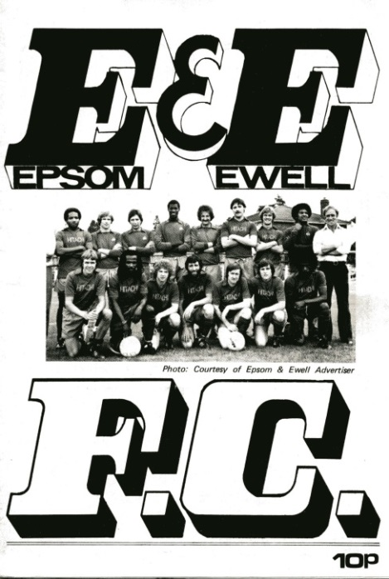
42 years ago today scoring sensation Tommy Tuite scored all five goals in a 5-2 Athenian League win at Grosvenor Vale, home of the now defunct Ruislip Manor. Tommy would repeat this feat eight seasons later at Windsor & Eton. Ruislip’s old ground is still alive and kicking and became the new home of Wealdstone a few years back.

39 years ago today Tony Pommell scored a hat trick as we defeated Civil Service 6-0 in a London Senior Cup tie. The Service were an original founder member of the Isthmian League although had spent many decades since in Amateur Football Association competition. (see programme pictured)

34 years ago today we destroyed Leytonstone & Ilford 5-1 on their own patch with Steve Hill scoring three goals and Tommy Tuite getting the other two. We had just won our first match in the Isthmian League Premier Division three days previously against Hitchin Town and this released the floodgates against one of the more famous names in Amateur football. We didn’t realise it at the time but they would be relegated at the end of the season and would leave Granleigh Road a couple of years later. Epsom never visited the quaint three-sided venue again.

30 years ago this week we looked to be heading out of the F.A. Vase at Merland Rise as we trailed 1-0 with time running out, only for Brian Perkins to score an equaliser from close range and Richard Strong popped up with the winner in extra time. A Second Round tie with Three Bridges awaited us in the next round.

Centre page for results

Centre page for results

CCL Division One Club Directory
AC LONDON: Telephone: 0208 660 5491 - Colours: Orange/Black/Black
Ground: Whyteleafe FC - 15 Church Road, Whyteleafe. CR3 0AR

ASH UNITED: Telephone: 01252 344264 - Colours: Green with Red Trim/Green/Green
Ground: Shawfields Stadium, Youngs Drive, Shawfields Road, Ash, Aldershot. GU12 6RE

BAGSHOT: Telephone: 01252 623804 - Colours: Yellow/Black/Black
Ground: Fleet Town FC - Calthorpe Park, Crookham Road, Fleet. GU51 5FA

BEDFONT & FELTHAM: Telephone: 0208-890 7264 - Colours: Yellow/Blue/Blue

Ground: The Orchard, Hatton Road, Bedfont. TW14 9QT

BRITISH AIRWAYS: Telephone: 0208-890 7264 - Colours: Sky Blue/Navy Blue/Navy Blue
Ground: Bedfont & Feltham FC - The Orchard, Hatton Road, Bedfont. TW14 9QT

CHESSINGTON & HOOK UNITED: Telephone: 01372-602263 Colours: All Blue
Ground: Chalky Lane, Chessington. KT9 2NF

COVE: Telephone: 01252 543615 Colours: Yellow/Black/Black
Ground: Oak Farm, Squirrel Lane, Cove GU14 8PB

DORKING WANDERERS RES Telephone: 01306 400151 - Colours: Red & White Stripes/ Blue/ Red
Ground: Meadowbank Stadium, Mill Lane, Dorking. RH4 1DX

EPSOM & EWELL Telephone: 01737-553250 - Colours: Royal Blue & White Hoops/Royal Blue/Royal Blue - Ground: Chipstead FC, High Road, Chipstead. CR5 3SF

EVERSLEY & CALIFORNIA Telephone: 0118 973 2400 - Colours: - White & Royal Blue Hoops /Royal Blue/ Royal Blue - Ground: Fox Lane, off Reading Road, Eversley. RG27 0NS

FARNHAM TOWN Telephone: 01252 715305 - Colours: - Claret & Sky Blue /White/ Claret & Blue
Ground: Memorial Ground, Babbs Mead, West Street, Farnham. GU9 7DY

FC DEPORTIVO GALICIA Telephone: 0208 831 9067 - Colours: Royal Blue/Royal Blue/White
Ground: Bedfont Sports FC - Bedfont Sports Club, Hatton Road, Bedfont. TW14 9JR

FLEET SPURS Telephone: 01252 662810 - Colours: Dark Blue with Red Trim/Dark Blue/Dark Blue
Ground: Kennels Lane Farnborough. GU14 0ST

FRIMLEY GREEN Telephone: 01252 835089 - Colours: All Blue
Ground: Frimley Green Recreation Ground, Frimley Green Road, Frimley. GU16 6JY

GODALMING TOWN Telephone: 01483 417520 - Colours: Yellow/Green/Yellow
Ground: Wey Court, Meadrow, Godalming. GU7 3JE

KENSINGTON BOROUGH Telephone: 01372 360151 - Colours: All Blue
Ground: Leatherhead FC – Fetcham Grove, Guildford Road, Leatherhead. KT22 9AS

SANDHURST TOWN Telephone: 01252 878768 - Colours: Red & Black Stripes/Black/Black
Ground: Bottom Meadow, Sandhurst Memorial Park, Yorktown Road, Sandhurst. GU47 9BJ

SHEERWATER Telephone: 01483 772470 - Colours: Royal Blue & White/Royal Blue/Royal Blue
Ground: Woking FC - Laithwaite Community Stadium, Kingfield, Kingfield Road, Woking. GU22 9AA

TOOTING BEC Telephone: 0208 540 8843 - Colours: Black & White Stripes/White/White & Black
Ground: Raynes Park Vale FC – Prince George’s Playing Fields, Grand Drive, Raynes Park. SW20 9DZ

Player Sponsorship
Here is the new list for 2018/19, with new photos showing all of our players and Management that are available for sponsorship.

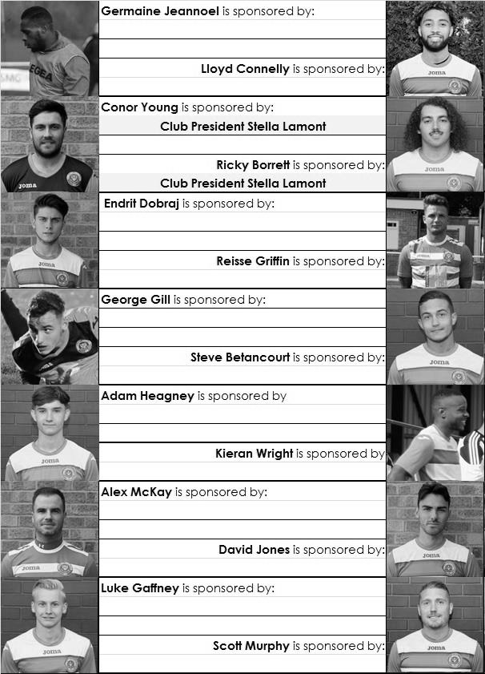

Sponsorship costs just £40 and it is easy to do. Just select a player who has not been previously sponsored and let a Committee Member know that you would like to sponsor them. Beware though. Until we have received the money it is possible for someone to jump in front of you, so don’t delay, sponsor today!

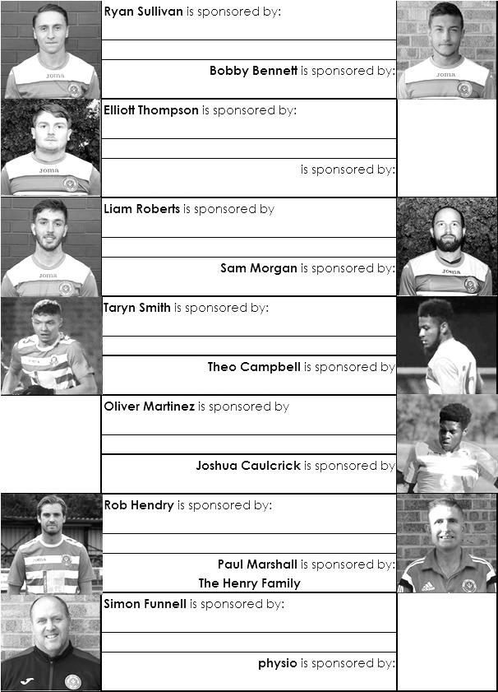

Match and Ball Sponsorships – 2018/19
Opponent | Date | Match Sponsor | Ball Sponsor
Chessington & Hook Utd | 21/08/18 | Club President - Stella Lamont
Beckenham Town (FAC) | 28/08/18 | Building Shop Ltd
Cove | 08/09/18 | EEFC Management Committee
Tooting Bec | 15/09/18 | Building Shop Ltd
Bagshot (LC) | 25/09/18
Sheerwater | 06/10/18 | Paul Merritt
Knaphill U23  (Surrey Premier Cup) | 23/10/18 | Jack Jarman
Frimley Green | 03/11/18 | The Chairman’s Grandchildren –  George, Joseph, Ezara and Inaya
Sandhurst Town (LD1C) | 06/11/18 | Richard Lambert
Kensington Borough | 17/11/18 | Jeff & Arnold Pye
Dorkinians (SPC) | 20/11/18
Dorking Wanderers Res | 27/11/18
Godalming Town | 01/12/18
Bedfont & Feltham | 08/12/18
Eversley & California | 29/12/18
Ash United | 12/01/19
Bagshot | 19/01/19
Farnham Town | 02/02/19
British Airways | 16/02/19
AC London | 02/03/19
FC Deportivo Galicia | 12/03/19
Fleet Spurs | 06/04/19
Sandhurst Town | 20/04/19 | Club President - Stella Lamont
Unknown (LC) |  | 3rd Round – might be at home
Match sponsorship costs just £60.00!

Sponsorship includes:

Admission, programmes and hospitality for three people.

A full page advert in the programme and mascot for the day (if required).

If you are interested, just speak to a Committee Member,
or drop me an email at: richard.c.lambert@gmail.com

Sandhurst Town F.C. – History
Sandhurst Football Club was formed in 1910 and played in the Reading & District League until 1979 apart from a short spell in the East Berkshire Football League. In 1979, the Club was elected into the Aldershot & District Football League. 1984 saw the Club finish as runners-up from whence they became founder members of the Chiltonian Football League and a stepping-stone toward becoming a senior club.

The best season in the Chiltonian Football League was in 1986-1987 when they finished in second place. In 1990 the Club applied for membership of the Combined Counties Football League and were granted senior status by the Berks & Bucks County Football Association. The first two seasons were disastrous finishing in bottom place on each occasion and only escaped relegation back to the Chiltonian Football League at the end of the second season due to the resignation of another member club. However, the form of the Club improved dramatically thereafter over a number of years with Managers Peter Browning and subsequently John Underwood bringing the club cup and league success.

The first ground used by the Club was a field adjacent to the Bull & Butcher public house that may well have been used as the club headquarters. After a few years, a move was made to the Memorial Park where the Club remained until the 1996 close season, apart from a couple of seasons during the 1950’s spent on a nearby pitch in St. John’s Road.

The introduction of the National Lottery prompted an immediate bid for funding for a new ground in Bottom Meadow adjacent to the Memorial Park. With support and backing through additional matched funding from Bracknell Forest Borough Council and Sandhurst Town Council, the Club were successful in the first round of allocations by the National Lotteries Charities Board.

The introduction of the National Lottery prompted an immediate bid for funding for a new ground in Bottom Meadow adjacent to the Memorial Park. With support and backing through additional matched funding from Bracknell Forest Borough Council and Sandhurst Town Council, the Club were successful in the first round of allocations by the National Lotteries Charities Board. The new facilities opened in August 1997 at a cost of £265,000. The club celebrated its Centenary season in 2010/11 winning the Combined Counties League Cup Final and getting through to two other semi-finals.

The club has a strong stable, business, financial and community focus today running teams in U18 Allied Counties Youth League and a new women’s team this season in WSL 4 the Southern Region Women’s Football League, as well as a Sunday team in the Aldershot & Camberley District Sunday League. This season a major revamp and a new experienced 1st team management under Michael Herbert and Darryl Jelly also saw us return to Division One of Combined Counties League after an enjoyable two years in the Hellenic League Division 1 finishing in 4th place.

All the latest Fizzers news on Twitter @sandhursttownfc.

Esoteric Combined Counties League
Division One Cup - Second Round
Tuesday, 6th November 2018 - Kick-off 7.45 p.m.
Epsom and Ewell  (Royal Blue & White hoops) | V |  | Sandhurst Town  (Red/Black Stripes/ Black/Black)
Squad | NUMBERS |  | Squad
Conor Young |  |  | Ryan Howells
Adam Heagney |  |  | Matthew Watson
Reisse Griffin |  |  | Josh Baker
Lloyd Connelly |  |  | Joe Barley
Steve Betancourt |  |  | Adam Barnard
Ryan Sullivan |  |  | Jamie Barrett
Liam Roberts |  |  | Gregory Beckett
© Scott Murphy |  |  | Luke Burrows
Jamie Watts |  |  | Mitchel Cooper
Elliott Thompson |  |  | Thomas Cooper
Bobby Bennett |  |  | Luke Cox
Rob Hendry |  |  | Ieuan Dimech
Germaine Jeannoel |  |  | Joshua Drew
Endrit Dobraj |  |  | Sam Green
David Jones |  |  | Jordan Goddard
Joshua Caulcrick |  |  | Richard Jones
Taryn Smith |  |  | Amin Khomsi
Alex McKay |  |  | Abdul Kamara
Ricky Borrett |  |  | Danny Langford
Olly Martinez |  |  | Ashley Ledger
Scott Elgar |  |  | Robert Mitchell
Simon Funnell | MANAGER |  | Michael Herbert
 | ASST MANAGER |  | Darryl Jelly
Sam Morgan | COACHES |  | Ben Greenslade
 | PHYSIO |  | Alice Workman
REFEREE: T.Inanc
ASSISTANTS: R.Wells, P.Maskell
Today’s match is sponsored by
Media Officer Richard Lambert

OUR NEXT VISITORS TO HIGH ROAD
Kensington Borough
Combined Counties League – Division One
Saturday, 17th November 2018 – 3.00 pm

